Муниципальное автономное общеобразовательное учреждение
«Средняя общеобразовательная школа № 38»
(МАОУ «СОШ № 38»)
«38 №-а шöр школа» муниципальнöй асъюралана велöдан учреждение

Методическая разработка заданий
для развития функциональной (читательской) грамотности
на уроках английского языка

Выполнила учитель английского языка:
Думкина В.В.

2022 г.
Аннотация
Данная методическая разработка представляет собой обзор текстовых заданий различных типов для обучения читательской грамотности и правила работы над ними.
Цель: формирование функциональной (читательской) грамотности обучающихся на уроках английского языка.
Вопросам обучения чтению в образовании всегда придавалось большое значение, задача развития читательской грамотности является новой областью для современной школы, решающей задачи реализации требований ФГОС, что обуславливает актуальность данной проблемы.
Читательская грамотность – это составляющая функциональной грамотности, это способность понимать и использовать письменные тексты, размышлять о них и заниматься чтением для того, чтобы достигать своих целей, расширять свои знания и возможности, участвовать в социальной жизни.
Одной из основных задач при обучении любому предмету становится обучение учащихся навыкам работы с любыми текстами.
Функциональное чтение – это чтение с целью поиска информации для решения конкретной задачи или выполнения определенного задания. При функциональном чтении применяются приемы просмотрового чтения (сканирования) и аналитического чтения (выделение ключевых слов, подбор цитат, составление схем, графиков, таблиц). Ученик, у которого сформированы навыки функционального чтения, может «свободно использовать навыки чтения и письма для получения информации из текста – для его понимания, сжатия, преобразования и т.д.
Выделяют три группы читательских умений:
1) Ориентация в содержании текста (умение определять главную тему, общую цель или назначение текста; выбирать из текста или придумать заголовок; формулировать тезис, выражающий общий смысл текста; объяснять порядок частей, содержащихся в тексте; находить в тексте требуемую информацию и т.п.).
2) Преобразование и интерпретация текста (умение преобразовывать текст, используя новые формы представления информации: формулы, графики, диаграммы, таблицы; сравнивать и противопоставлять заключённую в тексте информацию разного характера; обнаруживать в тексте доводы в подтверждение выдвинутых тезисов и т.п.).
3) Оценка информации (откликаться на содержание текста; оценивать утверждения, сделанные в тексте, исходя из своих представлений о мире; находить доводы в защиту своей точки зрения и т.п.).
Овладение этими умениями и означает «смысловое чтение», которое является фундаментом всех обозначенных в новом стандарте результатов образования.
В формировании функциональной грамотности учащихся способствуют задания с использованием сплошных и несплошных текстов.
К сплошным текстам относят тексты, читаемые в повседневной жизни (отрывок из рассказа, стихотворения, описание человека, места, предмета, рассказ, стихотворение, повесть, басня, письмо, статья в газете или журнале, статья в учебнике, инструкция, реклама, краткое содержание фильма, спектакля, пост блога, материалы различных сайтов, сочинение-размышление, комментарий, аргументация собственного мнения и т.д.).
К не сплошным текстам относятся графики, диаграммы, таблицы, схемы (кластеры), географические карты и карты местности, план помещения, входные билеты, расписание движения транспорта, карты сайтов и т.д.
Основные требования к тексту, направленному на формирование навыков функциональной читательской грамотности:
1.Текст должен быть ученику интересен.
2.Текст должен содержать неизвестную ученику информацию.
3.Текст должен развивать кругозор.
4.Текст не должен быть перегружен цифрами, датами, терминами.
5. Иллюстрации не отвлекают, а помогают разобраться в содержании текста. Иллюстрации должны способствовать развитию познавательной активности.
6.Уровень трудности текста должен соответствовать возрасту ученика. При необходимости нужно адаптировать текст.
7. Незнакомые слова должны «вычитываться» из текста или быть представлены в сносках.
8. Объем текста не должен превышать норму.
9. Шрифт должен помогать ученику легко читать текст.
10.Текст должен быть структурирован.
11.В тексте не должно быть ошибок
При выборе или составлении заданий следует учитывать следующие требования:
1.Задания должны быть пронумерованы.
2. К каждому заданию должна быть составлена чёткая инструкция.
3.Должна быть определена четкая форма ответа или рекомендации по возможной форме.
4. Оформление текста должно быть привлекательным, но не отвлекающим внимание от текста.
5. В одном задании не должно быть более одного вопроса (где / как).
6. Шрифт должен быть легко читаемым.
7. Нельзя допускать орфографические, пунктуационные и речевые ошибки.
8. Задания должны быть разнообразны и по виду деятельности.
9. Задания должны соответствовать цели.
10. Задания должны быть разного уровня сложности.
Материал для составлений заданий по проверке функциональной грамотности можно брать из жизненно важных проблем: поиск информации о работе, заполнение электронных анкет, опросов, анкет регистрации, поиск билетов на все виды транспорта, работа с информацией о возможностях отдыха и развлечений, поиск информации о фильмах, книгах, музыке, выбор товаров в Интернете, экскурсия.
Таким образом, использование на уроках английского языка различного вида текстовых заданий способствует развитию функциональной грамотности учащихся, грамотности чтения и комплексному освоению учащимися основных видов речевой деятельности, а также развивает творческое мышление, приучает учащихся к внимательному и вдумчивому отношению к тексту.
Данное методическое пособие содержит 5 сплошних и 5 несплошных текстов. После каждого текста предложены 3-4 разных задания для проверки понимания прочитанного.

Задания для развития функциональной (читательской) грамотности
на уроках английского языка

Unbroken texts (сплошные тексты)
Text № 1
Runners
Feel good in your runners
For 14 years the Sports Medicine Centre of Lyon (France) has been studying the injuries of young sports players and sports professionals. The study has established that the best course is prevention … and good shoes.
Knocks, falls, wear and tear...
Eighteen per cent of sports players aged 8 to 12 already have heel injuries. The cartilage of a footballer’s ankle does not respond well to shocks, and 25% of professionals have discovered for themselves that it is an especially weak point. The cartilage of the delicate knee joint can also be irreparably damaged and if care is not taken right from childhood (10–12 years of age), this can cause premature osteoarthritis. The hip does not escape damage either and, particularly when tired, players run the risk of fractures as a result of falls or collisions. According to the study, footballers who have been playing for more than ten years have bony outgrowths either on the tibia or on the heel. This is what is known as “footballer’s foot”, a deformity caused by shoes with soles and ankle parts that are too flexible.
Protect, support, stabilise, absorb
If a shoe is too rigid, it restricts movement. If it is too flexible, it increases the risk of injuries and sprains. A good sports shoe should meet four criteria: Firstly, it must provide exterior protection: resisting knocks from the ball or another player, coping with unevenness in the ground, and keeping the foot warm and dry even when it is freezing cold and raining. It must support the foot, and in particular the ankle joint, to avoid sprains, swelling and other problems, which may even affect the knee. It must also provide players with good stability so that they do not slip on a wet ground or skid on a surface that is too dry. Finally, it must absorb shocks, especially those suffered by volleyball and basketball players who are constantly jumping.
Dry feet
To avoid minor but painful conditions such as blisters or even splits or athlete’s foot, the shoe must allow evaporation of perspiration and must prevent outside dampness from getting in. The ideal material for this is leather, which can be waterproofed to prevent the shoe from getting soaked the first time it rains.
1. What does the author intend to show in this text?
A. That the quality of many sports shoes has greatly improved.
B. That it is best not to play football if you are under 12 years of age.
C. That young people are suffering more and more injuries due to their poor physical condition.
D. That it is very important for young sports players to wear good sports shoes.

2. According to the article, why should sports shoes not be too rigid?
________________________________________________________________________________________________________________________________________

3. One part of the article says, “A good sports shoe should meet four criteria.” What are these criteria?
________________________________________________________________________________________________________________________________________________________________________________________________________________________________________________________________________________

4. Look at this sentence from near the end of the article. It is presented here in two parts:
“To avoid minor but painful conditions such as blisters or even splits or athlete’s foot (fungal infections),…” (first part)
“…the shoe must allow evaporation of perspiration and must prevent outside dampness from getting in.” (second part)
What is the relationship between the first and second parts of the sentence?
A the second part contradicts the first part.
B. repeats the first part.
C. illustrates the problem described in the first part.
D. gives the solution to the problem described in the first part
Text № 2
The ultimate survivor
When he was 20, he broke his back in three places in a parachuting accident. He climbed Mount Everest at the age of 23. Shortly afterwards, he led a trek across the frozen North Atlantic.
In 2007, he set another world record by flying over Mount Everest in a powered paraglider. This helped to raise one million dollars for the Global Angels Foundation, a charity that supports children in Africa.
His first book, Facing the Frozen Ocean, got shortlisted for the UK’s ‘Sports Book of the Year’. Since then he has written more than 15 books, including the No 1 Bestseller: Mud, Sweat and Tears.
His name is Bear Grylls, and he was the host of Discovery Channel’s famous TV show, Man vs Wild. In the show, he was left stranded in remote locations in order to demonstrate survival techniques. Millions of viewers watched, breathless, as he killed the most poisonous snakes and ate them, climbed extremely dangerous cliffs, parachuted from helicopters and balloons, performed amazing ice climbing stunts, ran through a forest fire, and ate all kinds of insects.
Grylls continues to impress with both his amazing shows, and his incredible charity work. And he has set up his own company, Bear Grylls’ Survival Academy, where everyone can learn survival skills from him and his team of highly trained experts. Recently, Grylls founded Young Survivors - training courses for teenagers, comprising a combination of survival skills and adventure tasks designed to teach the fundamentals of outdoor survival and self-rescue. Those who complete the course are given a Young Survivors Award. Techniques taught include how to build and light a fire, how to navigate in both day and night, building a shelter, extreme weather survival, tracking and hunting and tying knots. A key focus of the course is getting young survivors back in touch with nature and away from technology.
In Grylls’ own words: ‘The thing I love about the Young Survivor Course is that it is designed to put young adults in just the sort of challenging, character-building and practical situations that help define and distinguish people as adults. So often, youngsters can feel almost over-protected and are stopped from experiencing some of the best things in life - but the Young Survivor Award will challenge and empower hem in an incredibly dynamic and fun environment.'

- Which of these things do you think you could learn from Bear Grylls? Read the article and put the ticks:
- how to build a fire
- how to use GPS effectively
- how to build a shelter in the wild
- how to survive outdoors in bad weather
- how to set up your own survival website
- how to tie knots

- Answer these questions based on your own opinions. Use evidence from the text to support your ideas.
1) What do you think motivates Bear Grylls?
_____________________________________________________________
2) Why are his TV shows so popular?
_____________________________________________________________
3) Do you think Bear Grylls is successful? Why (not)?
_____________________________________________________________
4) What does Bear Grylls think of the way many young people grow up these days?
_____________________________________________________________

3. Read the sentences and correct the mistakes:
1) This helped to raise one million dollars for the Global Angels Foundation, a charity that supports disabled people in Africa.
2) In the show, Bear was left stranded in tropical rainforests in order to demonstrate survival techniques.
3) He has set up his own company, Bear Grylls’ Survival Academy, where everyone can learn driving skills from him and his team of highly trained coaches.
4) Techniques taught include how to put a tent, how to navigate in both day and night, building a hut, extreme weather survival, tracking and hunting and fishing.
5) The thing I love about the Young Survivor Course is that it is created to put young adults in just the sort of education.
6) A key focus of the course is getting young survivors back in touch with parents and away from computers.
Text № 3
A kind of loving
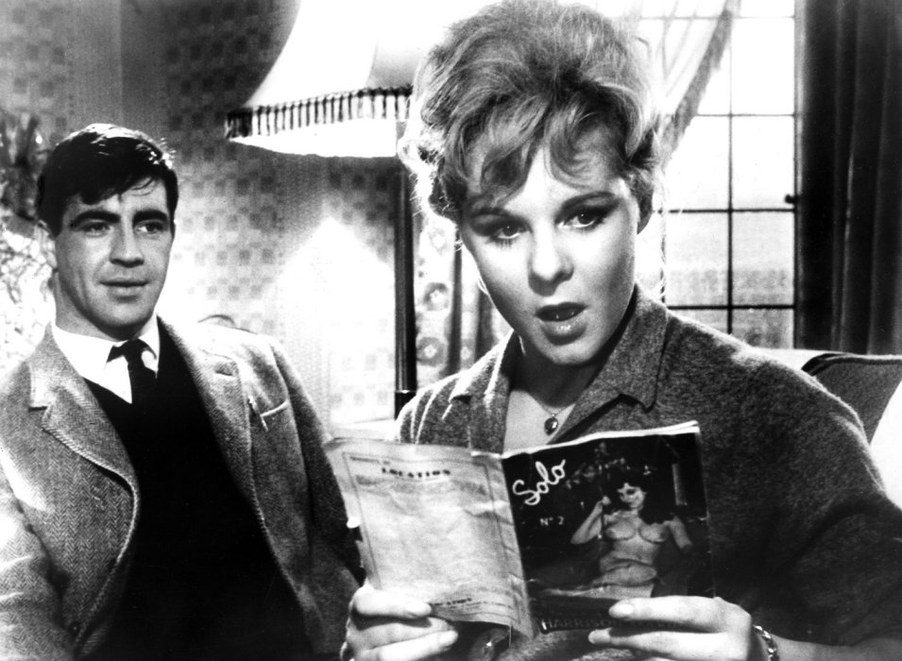
Vic Brown is a young draughtsman at an engineering works in northern England in the 1950s. He lives with his mother and father. He is attracted to one of the secretaries at the engineering works - Ingrid Rothwell - and one day, as they leave work, they run into each other and start walking to the bus stop together.
I ’m going your way,’ she says. I hold the door open for her and get a gorgeous whiff of her scent as she goes by. We say good night to the commissionaire and walk off down the lane. [...] It seems there’s a lot I don’t know and she starts to bring me up to date. I don’t have to make the conversation tonight; she just rolls it out. She’s as full of scandal as the Sunday papers and by the time we get to the bus stop I know more about the people who work at Whittaker’s than I’ve learned all the time I’ve been there. I get both fares into town and she says, ‘That makes us quits,’ and smiles.
She picks up where she left off and starts chattering again; but I’m not really listening now. My mind’s working like mad on how I can make the most of this chance. I try to think of a way to get started and all the time the bus is tearing down the road into town. When I see the Grammar School sail by I kind of panic because I know we’ll be in the station any minute now. ‘Look, there’s something I -’ And she starts talking again at the same time.
We both stop. ‘Go on,’ I say. ‘I was just going to ask you if you’d seen that new musical Rise and Shine at the Palace,’ she says. ‘I was wondering what it was like.’ I haven’t a clue what it’s like, to be honest, but I say, ‘I think it’s good,’ and I’m thinking, Now, now, now: what are you waiting for? ‘I was thinking of going to see it myself one night this week, as a matter of fact,’ I say. This is another fib, but I don’t care. I have to dear my throat.
‘P’raps ... er, mebbe you’d like to come with me ... see it together She says, ‘Oh!’ just as if it was the last thing she’d have thought of and I begin to think how I can pass it off if she turns me down. ‘Well, when?’ I can hardly sit still in the seat. I want to jump up and shout, I’m that excited. ‘I’d thought of going tomorrow, but any night ’ud suit me really.’ ‘Tomorrow’s New Year’s Eve,’ she says, ‘and I’m going to a party. Can you make it Wednesday?’ ‘All right.’ Wednesday, Thursday, Friday, Saturday or Sunday. I can make it any night or all of them. I just want it to be soon. ‘Wednesday, then,’ she says, and I nod. ‘Wednesday.’ Before the bus pulls into the station we’ve fixed up what time we’ll meet and where and everything. And to think, only this morning wouldn’t have given a bent penny for my chances. But that’s how things work out sometimes. Wednesday ... I just don’t know how I’ll live till then. But course I do, and now here I am waiting on the corner at twenty-five to eight. She’s late, but only five minutes, and I was here ten minutes early to make sure I didn’t miss her so that makes it seem more.
By Stan Barstow

1. Read the extract. Answer the questions.
1 What does Ingrid talk about as she and Vic walk to the bus stop?
2 What is Vic thinking about as the bus approaches the station?
3 What two things does Vic say to Ingrid that aren't really true?
4 W hy does Vic want 'to jump up and shout'?
5 Why does it seem to Vic that Ingrid is later than she is?

2. Match the highlighted words and phrases in the extract with the definitions.
1 a lie; something someone says that’s not true
2 agreeing that no one owes anything to another person
3 things about other people that are shocking
4 be available (to meet or to do something)
5 someone who does drawings of machines, new buildings, etc.
6 a slight smell
7 going very, very fast
8 talking a long time about not very important things

3. Read the sentences and write T (True), F (False), NS (Not Stated):
1. Vic Brown is in love with Ingrid Rothwell. T/F/NS.
2. Ingrid Rothwell is a shy young girl. T/F/NS.
3. Ingrid wants to have a party on Friday. T/F/NS.
4. Vic Brown was waiting on the corner at twenty-five to five. T/F/NS.
Text № 4
The most unusual festival I've been to

Last year I visited a small village near the city of Gloucester, England, where a very special day and unusual race takes place once a year. It's called “Cooper's Hill Cheese-Rolling”. On a Saturday at the beginning of spring, people from all over the world, go to Cooper's Hill to see the race. The first written information about the race was in a message sent to the local government in 1826. _____ So nobody knows when it really started. Each year, the event becomes more and more popular with people coming from all over the world to take part and to watch. ______ .
The way the race works is as follows. There is a very large piece of cheese, which is round, like a wheel, and weighs about 4 kilograms. ______ One of the people in charge of the event sends the large piece of cheese down the hill and half a second later everyone taking part runs down the hill after the cheese. ______
In the past, the cheese has hit people watching the race and injured them. It's not just the spectators who get injured; many of the people running down the hill get serious injuries, too. The injuries are usually broken ankles and legs as the runners lose control coming down the steep hill. _____ There are also lots of local people helping to catch the runners, so they don't fall over and hurt themselves; they are called catchers.
This event become so famous that it appears on television all over the world on the BBC network and, also, on Trans World Sport. People watching this event think it is very strange and that the people taking part are crazy.
By Diane Key
- Read the sentences and put them into the correct place in the text. One sentence is extra.
A. It was wood around it to protect it.
B. The police think the event is very dangerous.
C. Winners of the event have come from the United Stated, Australia, New Zealand, and Nepal.
D. Sometimes they use an old tyre.
E. The words in the message showed that this event was already a tradition then.
F. That's why, at the bottom of the hill, there are lots of ambulances and medical staff.
G. The first person over the finnish line at the bottom of the hill wins the cheese.
H. Children are not allowed to eat the cheese.
2. Read the sentences and write T (True), F (False), NS (Not stated):
- Cooper's Hill Cheese-Rolling takes part every month. ______
- The race began in 1826. ______
- There are always a lot of journalists at the festival. _______
- The festival is very popular only in England. ________
- The cheese should weigh 6 kilograms. ________
- The race is completely safe. _______
- The race is well-known thanks for mass media. _______
- Only men can take part in the competitions. _______
- The winners get expensive presents, _______
3. Find the right endings for the sentences:
1. On a Saturday at the beginning of spring, people from all over the world, … .
- celebrate Christmas
- go to Cooper's Hill to see the race
- begin to find a new job.
2. Each year, the event becomes more and more popular with people coming from all
over the world to … .
- take part and to watch the event
- to sell their sports equipment
- to find a partner for marriage
3. In the past, the cheese has hit people watching the race and … .
- killed them
- injured them
- fed them
- There are also lots of local people helping to catch the runners, so they don't fall over and hurt themselves; they are called … .
- catchers
- watches
- winners

Text № 5
A b o u t a B o y
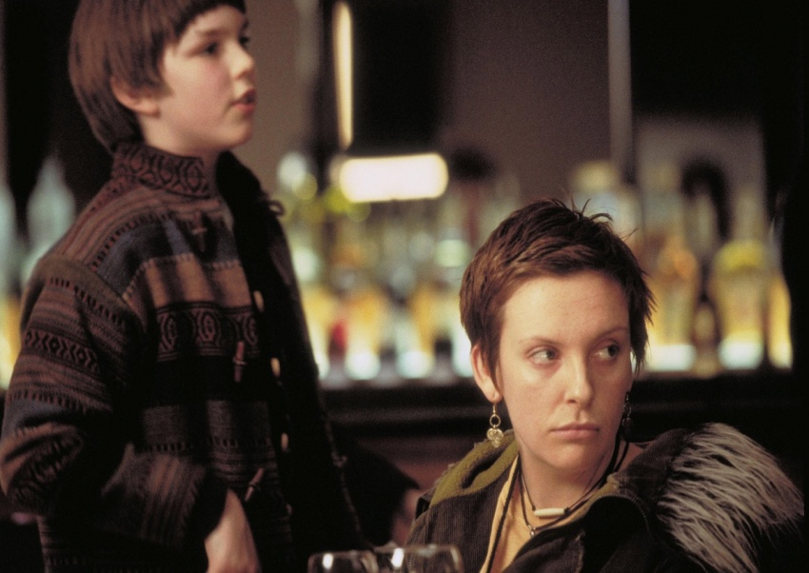
Marcus is a schoolboy who lives with his mum, who is depressed. Marcus has a bad time at school - he gets bullied quite a lot, especially because o f the clothes his mum makes him wear. Marcus has met Will, a rich lazy man who makes friends with Marcus and buys him new trainers. Here, Marcus and his mum are going home after visiting Will at his flat.
‘You’re not going round there again,’ she said on the way home.
Marcus knew she’d say it, and he also knew that he’d take no notice, but he argued anyway. '
'Mmm..Why not?’ ‘If you’ve got anything to say, you say it to me. If you want new clothes, I’ll get them.’
‘But you don’t know what I need.’ ‘So tell me.’
‘I don’t know what I need. Only Will knows what I need.’
‘Don’t be ridiculous.’
‘It’s true. He knows what things kids wear.’
‘Kids wear what they put on in the mornings.’
‘You know what I mean.’
‘You mean that he thinks he’s trendy, and that [...] he knows which trainers are fashionable, even though he doesn’t know the first thing about anything else.’ That was exactly what he meant. That was what Will was good at, and Marcus thought he was lucky to have found him.
‘We don’t need that kind of person. We’re doing all right our way.’ Marcus looked out of the bus window and thought about whether this was true, and decided it wasn’t, that neither of them were doing all right, whichever way you looked at it.
‘If you are having trouble it’s nothing to do with what shoes you wear, I can tell you that for nothing.’
‘No, I know, but - ’ ‘Marcus, trust me, OK? I’ve been your mother for twelve years. I haven’t made too bad a job of it. I do think about it. I know what I’m doing.’ Marcus had never thought of his mother in that way before, as someone who knew what she was doing. He had never thought that she didn’t have a clue either; it was just that what she did with him (for him? to him?) didn’t appear to be anything like that. He had always looked on being a mother as straightforward, something like, say, driving: most people could do it, and you could mess it up by doing something really obvious, by driving your car into a bus, or not telling your kid to say please and thank you and sorry (there were loads of kids at school, he reckoned, kids who stole and swore too much and bullied other kids, whose mums and dads had a lot to answer for). If you looked at it that way, there wasn’t an awful lot to think about. But his mum seemed to be saying that there was more to it than that. She was telling him she had a plan. If she had a plan, then he had a choice. He could trust her, believe her when she said she knew what she was doing [... ] Or he could decide that, actually, she was off her head [... ] Either way it was scary. He didn’t want to put up with things as they were, but the other choice meant he’d have to be his own mother, and how could you be your own mother when you were only twelve? He could tell himself to say please and thank you and sorry, that was easy, but he didn’t know where to start with the rest of it. He didn’t even know what the rest of it was.
by Nick Hornby

1. Read the extract again. Find the part of the text which tells us that Marcus...
- is 12 years old.
- and his mother are not walking home.
- thinks that both he and his mother have problems.
- begins to see his mother differently.
- doesn’t think very highly of some of the kids at his school.
- is happy that he has met Will.
2. Match the highlighted words in the extract with the definitions.
- up-to-date with modern fashion
- do it in a really bad way
- knows nothing at all
- simple; not complicated
- give advice for free
- used bad words (words that people think are rude)
- crazy
- no matter how
3. Read the sentences and write T (True), F (False), NS (Not Stated):
1. Marcus has bad relations with his classmates. T/F/NS.
2. In Marcus's class all pupils are from rich families. T/F/NS.
3. Marcus mother is happy that her son found Will. T/F/NS.
4. According to Marcus mother human problems don't depend on clothes they wear. T/F/NS.
5. From the text we knew that Marcus quarrel a lot with his mum. T/F/NS.
6. Marcus thought that it is easy to be a parent. T/F/NS.

Broken texts (не сплошные тексты)
Text № 1
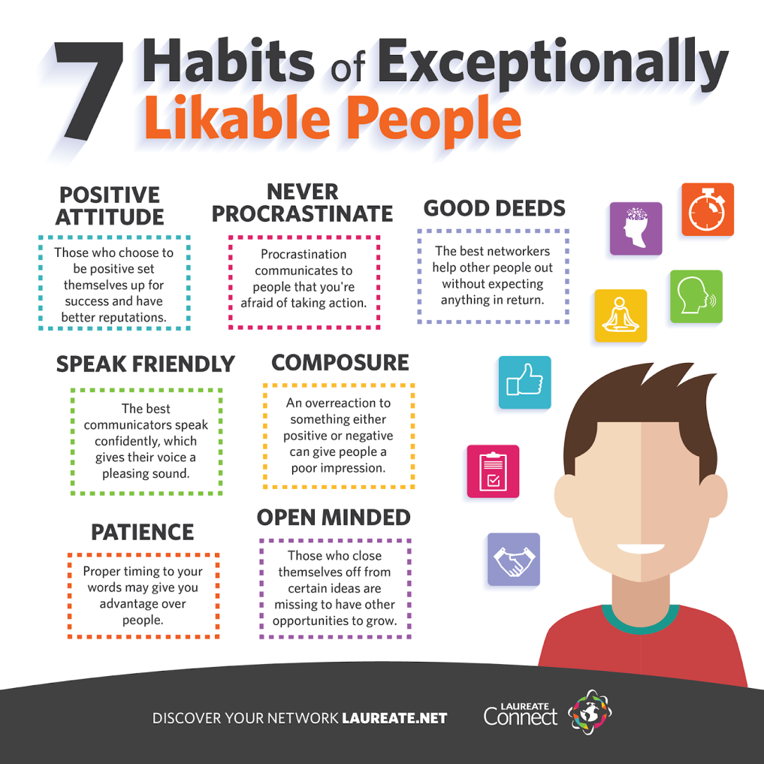

1. What is the main aim of this poster?
- to give teenagers some advice on how to improve their exam results
- to show teenagers what opportunities they can have if they will choose to study at a university
- to show the main features of character of a successful person
- to provide the readers with useful information about success in business
- Read the sentences and write T (True), F (False), NS (Not stated):

A. The best networkers help other people out without expecting anything in return _____.
B. Those who choose to be rude to people have better reputation ______.
C. You can be likable only if you pay attention to your look _____.
D. People who communicate confidently are more successful _____.
E. If a person wants to be more successful he shouldn't show too much his emotions _____.
F. Successful people always try to prove their opinion _____.
G. If a person wants to be successful he should be always open to new ideas and experience ______.
3. Choose from the list other features of likable people and give a short description of them as in the text above:

Creativity, intelligence, hypocrisy, closeness, rudeness, generosity, arrogance, kindness.

Text № 2
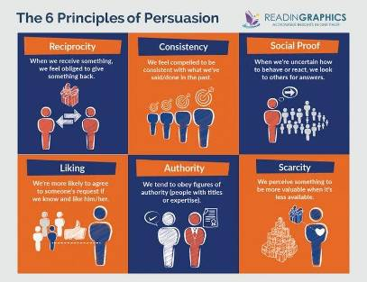

1. Who can be the target reader of this article?
- children under 10 years old
- adults of any profession
- medical staff
- teachers and scientists
2. Complete the sentences with a right ending:
a) When we receive something, we feel obliged to
- say thank you
- give something back
- take it for granted
b) We feel compelled to be consistent
- with what we've done or said in the past
- with the opinion of our relatives
- with the attitude of our colleagues
c) When we are uncertain how to behave or react
- we consult a psychologist
- we look to others for answers
- we search for advice in the internet
d) We're more likely to agree with someone's request
- if he/her is rich
- if he/she is a famous person
- if we know and like him/her
3. Read the following utterances and write after them Social proof, Authority, Liking:
A) We communicate with other people with enthusiasm if they share our point of view. ______________
B) We feel satisfied after our public speech if the audience listened attentively and asked questions. _______________
C) We obey our tutors if they have a high social status. _________________
D) We read a new book with more interest of it won a national price. _____________
E) We buy a new pair of shoe even if they are expensive if they were advertised on TV. _________________
F) We trust a new beautician more if she/he looks healthy and successful.
Text № 3
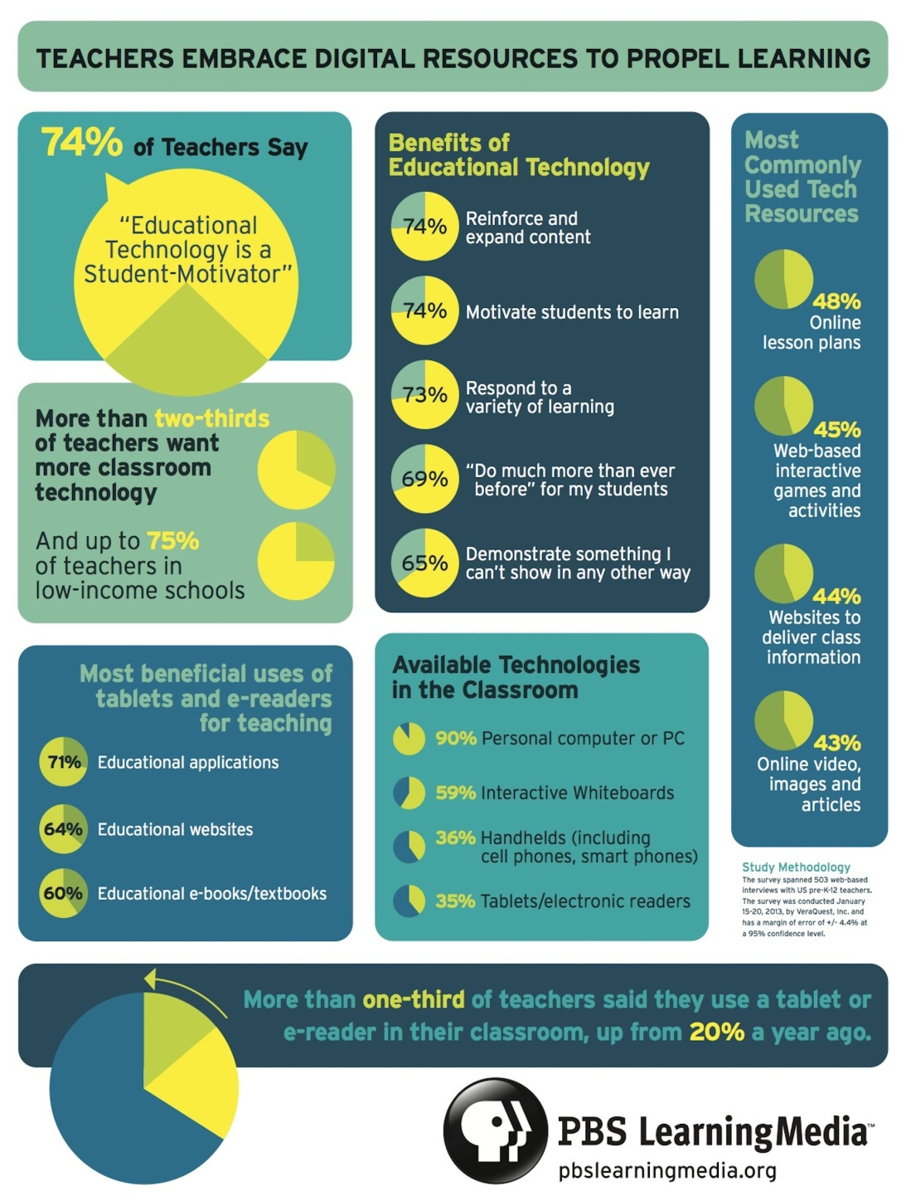
1. Where can you find this poster?
- in a business journal
- in an educational magazine
- in a travel brochure
- in a coursebook

- What can we learn from the poster? Tick the correct sentences.
  - There are five main benefits of Educational technologies. ___
  - The majority of teachers want more classroom technology. ____
  - Among most used resources tech resources there are online webinars for teachers. _____
  - Teachers say than current educational technology doesn't correspond to social needs. _____
  - From the poster we can what are the most beneficial uses of tablets and e-readers. _____
  - Pupils use educational resources more often than students. ____
  - We can learn what technologies are available in the classroom. ____

3. What conclusion can we draw form this poster?
  - The importance of educational technology is growing.
  - Teachers don't want to use mordern educational technologies because they have a negative impact on physological health of students.
  - The use of educational technology is expensive
  - Technology can be used only in High schools
Text №4
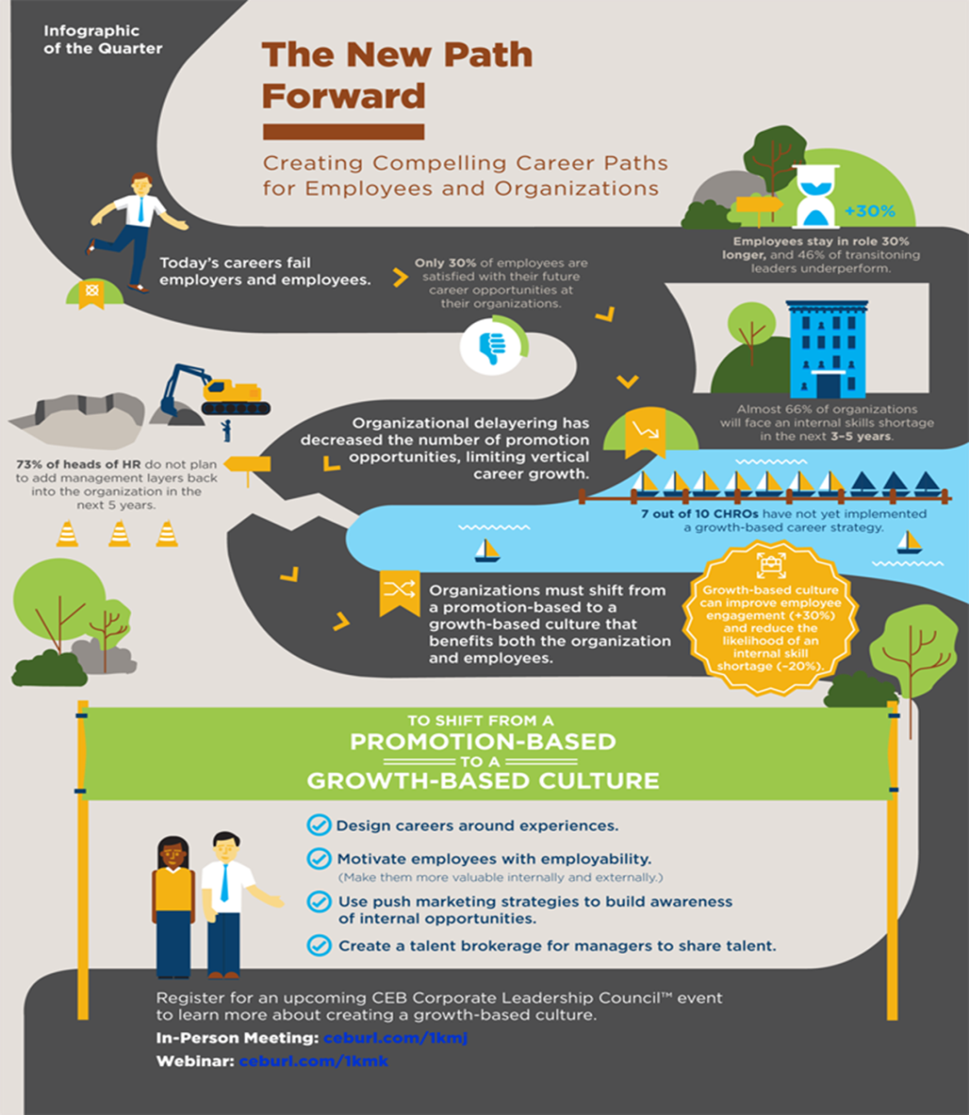

1. Who is a target reader of the poster?
- students
- employers
- politicians
- scientists

2. Mark (☑) the purposes of this poster:
- to show that employees get less interested in the career _
- involve financial support in business from the government _
- attract the public attention to the problems of employability _
- prove that employees who got the education abroad are more sussessful. _
- invite the target audience to a meeting _
- to inform about leasure activities for employees. _
- to show that we should refuse promotion-based culture and opt for growth-based culture in business. _

- Complete the sentences with a correct word:
- Almost 66 % of (companies/enterprises/organisations) with will face an internet skills of transitioning leaders underperform.
- Organizational delayering has (improved/decreased/spoiled) the number of promotion opportunities, limiting vertical career growth
- Organizations must (change/opt for/shift) from a promotion-based to a growth-based culture that benefits both the organization and the employees.
- Growth-based culture can (develop/improve/change) employee ingagement and reduce the likelihood of an internal skill shortage.
- 73 % of heads of HR do not plan to (add/exclude/delay) management layers back into the organization in the next 5 years.

Text №5
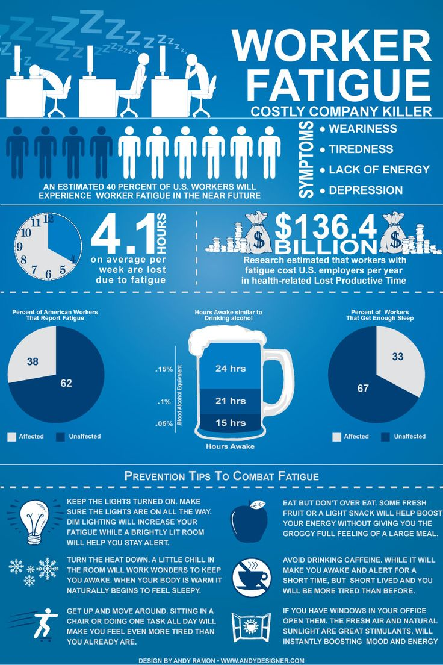
1. What is the main aim of this poster?
- provide the information how to improve relations on work
- inform readers about the negative impact of fatigue and how to prevent it
- explain the rules of a healthy lifestyle

2. Who is the target reader of this text?
- students
- workers
- teachers
- politicians
3. Read the sentences and correct the mistakes:
  - There are 4 main symptoms of fatigue: weariness, tiredness, lack of appitite and depression
  - Researchers estimate that workers with fatigue cost U.K. employers 135.4 billion dollars per year.
- To prevent fatigue you should keep the light dim.
- Some fresh fruit or a light snack will help boost your mood.
- If you keep the window shut in your office the fresh air and natural sunlight will be good stimulants.
- 4.1 hours of work per month are lost due to the fatigue.
- Avoid drinking tea while it will make you awake for a short period of time.

4. What the main conclusion we can make:
- employers should raise the salary
- we should avoid extreme fatigue because it may cause problems at work
- companies should pay attention to the physiological health of workers.
- business companies should provide comfortable conditions for workers.

